OUT PUTS OF SQL OF DATA ANALYSIS

* Use SELECT, WHERE, ORDER BY, GROUP BY
* Output of select and where:

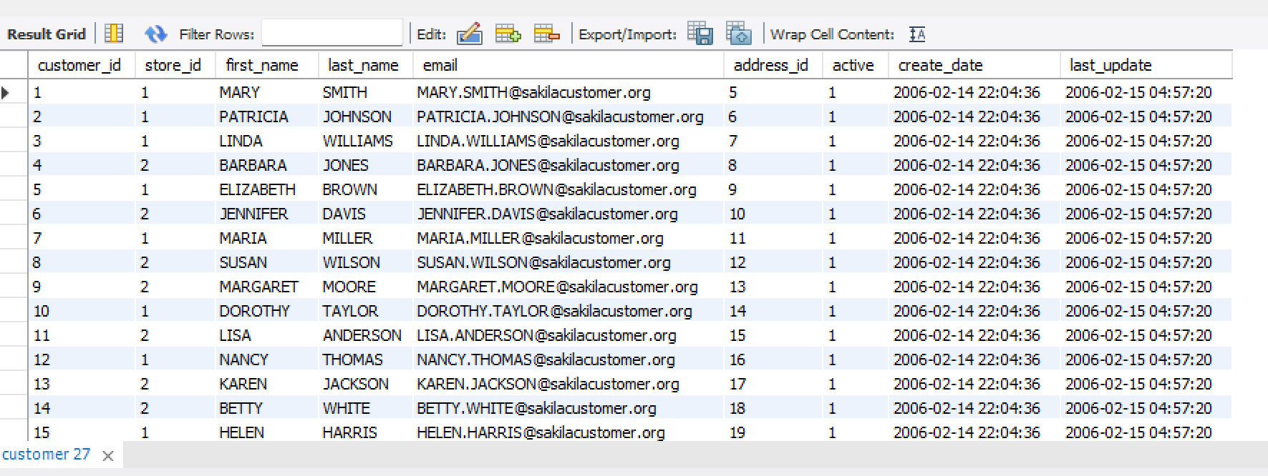

* Output of order by:

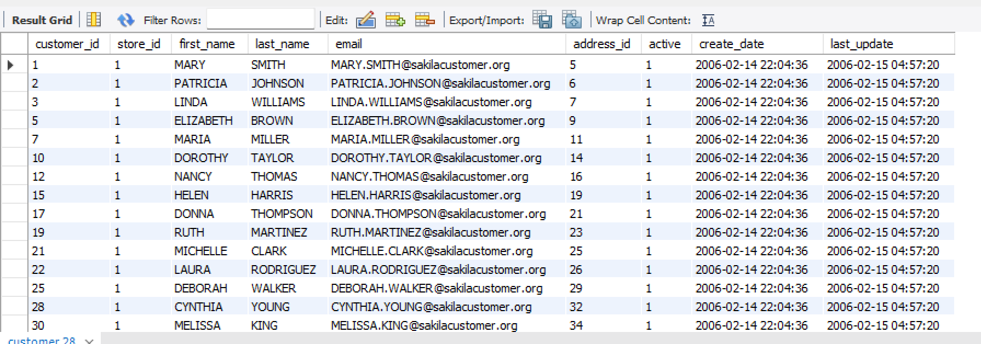

* Output of group by:

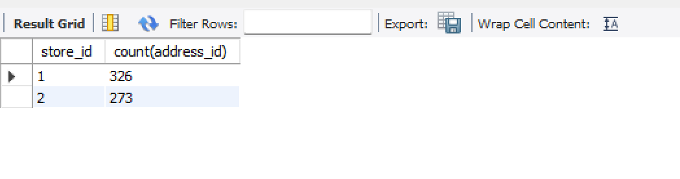

* Use JOINS (INNER, LEFT, RIGHT)
* Output of inner join:

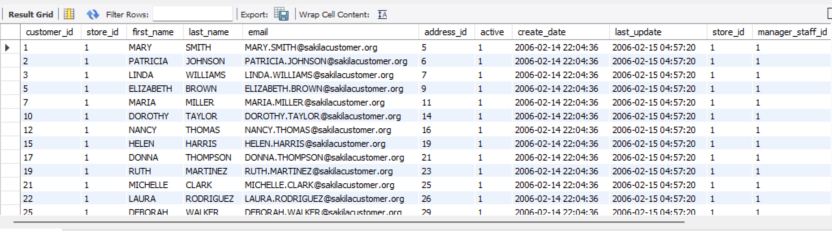

* Output of left join:

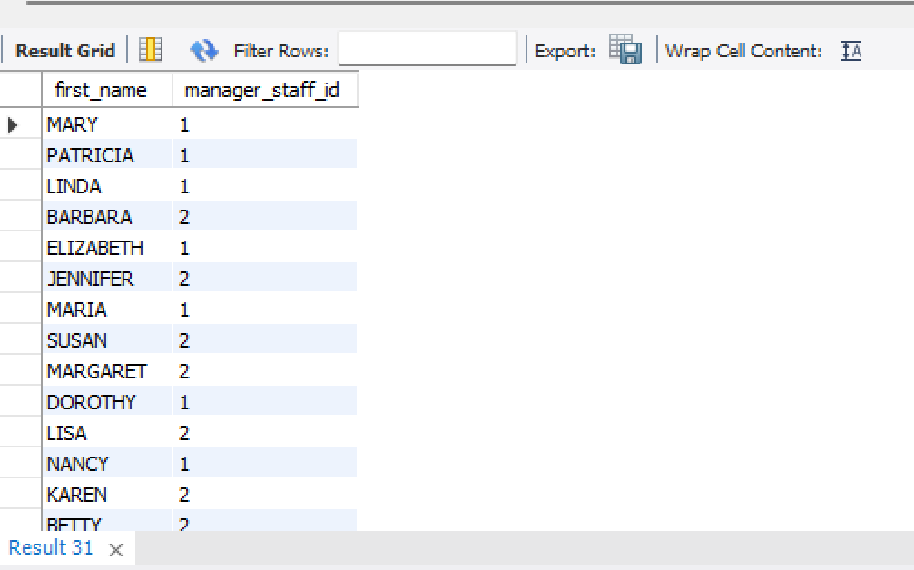

* Output of right join:

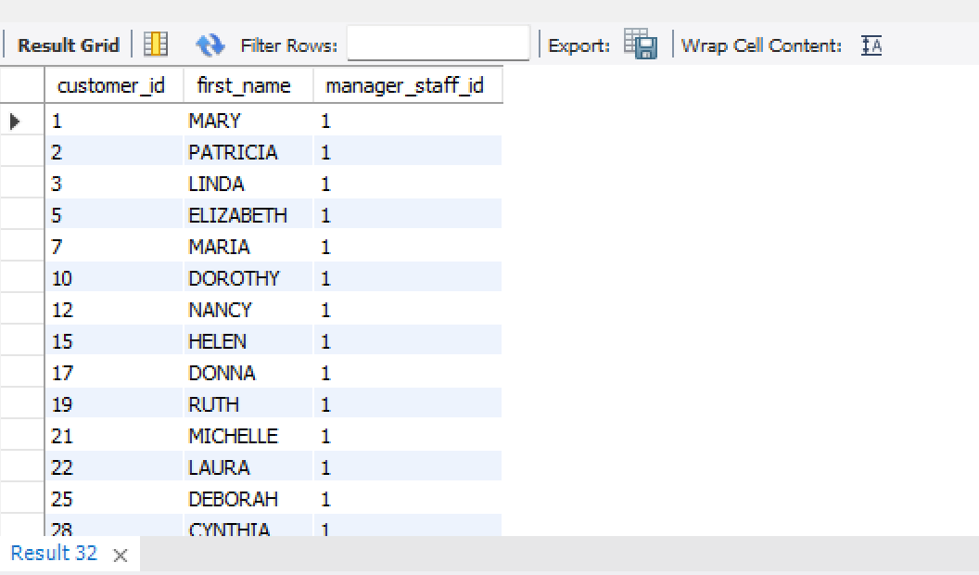

* Output of subqueries and aggregate functions of (Sum, Avg ):
* Output of Average:

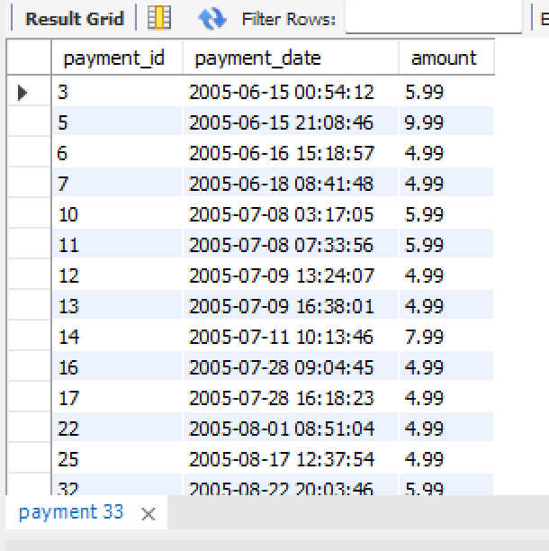

* Output of Create views for analysis :

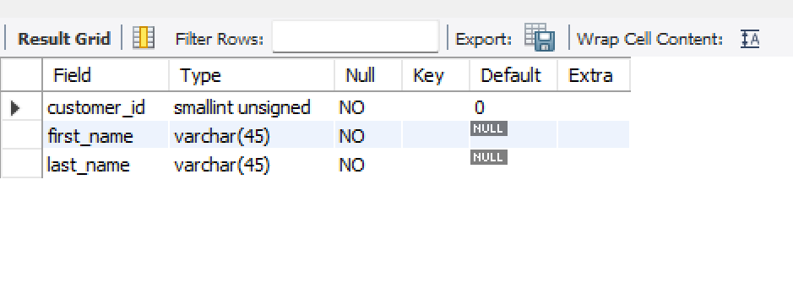

* Output of Optimize queries with indexes:

